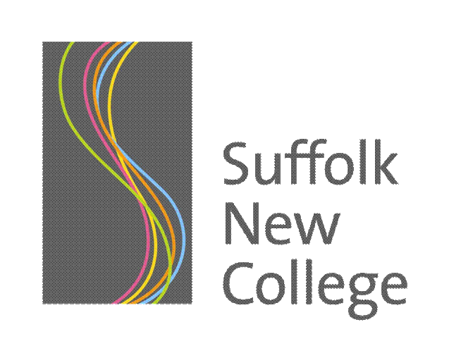

Declaration of Qualifications level 2/3 entitlement

Full Name:

D.O.B: Person Code:

Course Code:

Course Title:

I confirm that all the information on my enrolment form is correct and
Please Tick
I declare that I do not already have a full level 2 qualification or above.

I declare that I do not already have a full level 3 qualification or above.

I understand that if I have declared false information Suffolk New College may take action against me to reclaim the tuition fees and any support costs provided.

Signed (Learner):

Signed
(Suffolk New College):

Date:

For Office Use Only:

Official Stamp of the Learning Provider:

Waiver:

Date:

Initials:
(printed)

Academic Year:

